GUT CACAO: Crunchy Premium Cacao Nibs
B2B Sales Pitch – English Version
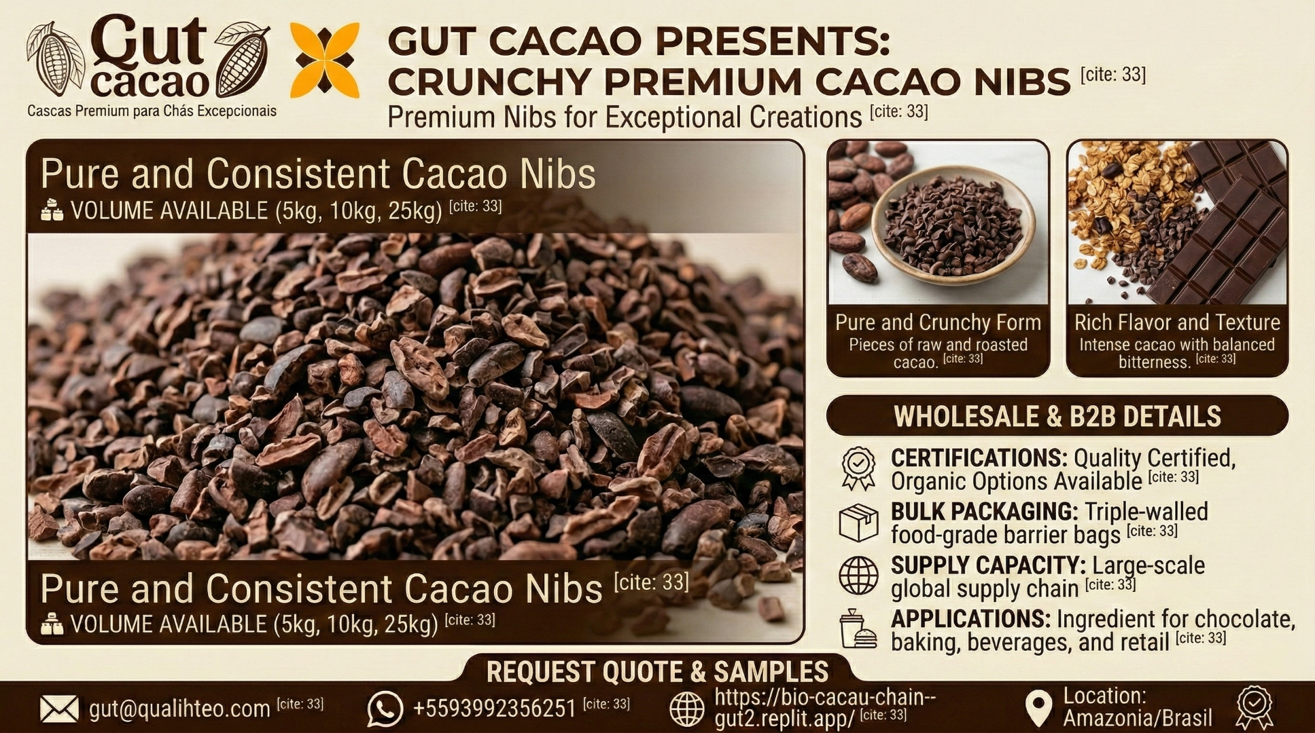

Pure Cacao Excellence in Every Bite
GUT CACAO presents Crunchy Premium Cacao Nibs – pure and consistent roasted cacao pieces sourced directly from the Amazon rainforest. The perfect ingredient for chocolate makers, confectioners, bakers, and premium food manufacturers who demand quality, flavor, and traceability.

Why Choose GUT CACAO Premium Cacao Nibs?
Pure and Crunchy Form
Our cacao nibs are pieces of raw and roasted cacao – nothing added, nothing removed. Just pure, crunchy cacao with the natural intensity and complexity that only Amazonian beans can deliver[1].
The clean cracking and winnowing process produces uniform nibs with minimal shell contamination, ready for immediate use in your formulations. No further processing required – just open and incorporate into your recipes[1].
Rich Flavor and Texture
Experience intense cacao with balanced bitterness, featuring deep chocolate notes with subtle fruity and earthy undertones. The satisfying crunch and robust flavor make these nibs ideal for inclusion in chocolate bars, granola, baked goods, confectionery toppings, and specialty beverages[1].
The roasting profile is carefully calibrated to develop complexity without losing the natural character of Amazonian cacao. Each bite delivers authentic chocolate intensity with a clean finish[1].
Consistency You Can Count On
Every batch undergoes the same rigorous post-harvest processing: digital fermentation monitoring (pH, Brix, temperature), precision solar-hybrid drying to 7% moisture, controlled roasting, and careful cracking and winnowing to produce uniform nibs[1].
This systematic approach ensures your formulas behave predictably batch after batch. No surprises, no reformulation, no customer complaints about inconsistent flavor[1].

Wholesale & B2B Details
Certifications: Quality certified with organic options available. Cocoa of Excellence Award Winner recognition for sourcing excellence[1].
Bulk Packaging: Available in 5 kg, 10 kg, and 25 kg packages. Triple-walled, food-grade barrier bags for optimal freshness and shelf stability during storage and transport[1].
Supply Capacity: Large-scale global supply chain with direct Amazon origin. Container and pallet shipments available with full batch traceability via QR code[1].
Applications: Ingredient for chocolate production, baking, confectionery toppings, granola and cereal bars, specialty beverages, and retail packaging.

The GUT CACAO Advantage: From Farm to Nib
- Traceable Origin: Every batch tracked from agroforestry systems in Pará, Brazil, with digital biometric reception and lot segregation. Scan the QR code to see the farm, fermentation data, and processing timeline[1].
- Advanced Fermentation: Wooden fermentation boxes with real-time pH, Brix, and temperature monitoring ensure optimal flavor development and Type 1 bean classification. Hydraulic turning at precise intervals guarantees even fermentation[1].
- Hybrid Precision Drying: Slow solar greenhouse drying (4–6 days) combined with smoke-free wood drying to exactly 7% moisture for food safety and extended shelf life. No smoke contamination, no over-drying[1].
- Controlled Roasting: Industrial roasting line with temperature and time control develops deep flavor while preserving natural antioxidants and polyphenols. Consistent roast profile across all batches[1].
- Clean Winnowing: Precision cracking and winnowing process produces uniform nibs (3-8mm typical size) with less than 2% shell content, ready for immediate use without further cleaning[1].

Technical Specifications
Product | Premium Roasted Cacao Nibs
Form | Cracked and winnowed pieces (3-8mm typical)
Moisture Content | 7% (controlled drying)
Shell Content | Less than 2% (clean winnowing)
Packaging Options | 5 kg, 10 kg, 25 kg bulk packages
Origin | Amazon rainforest, Pará, Brazil
Certifications | Quality certified, organic options available
Fermentation | Type 1 fermented beans, monitored protocol
Traceability | QR code per batch, farm to package
Storage | Cool, dry place, sealed packaging
Shelf Life | 18 months from production date

Table 1: GUT CACAO Premium Nibs Technical Specifications

Your Competitive Edge
Premium cacao nibs are a growing category in health foods, specialty chocolate, and artisan baking. The global superfood market is expanding rapidly, and authentic, traceable ingredients command premium pricing. GUT CACAO delivers:
Consistent size, flavor, and quality for formula stability – reduce R&D costs and reformulation headaches
Clean processing with minimal shell content for immediate use – no additional cleaning or sorting required
Compelling Amazon rainforest origin story for brand differentiation – consumers respond to authentic sustainability narratives
Direct relationship eliminating middleman costs and supply uncertainty – stable pricing and predictable availability
Flexibility in packaging sizes from small artisan batches to industrial scale – we grow with your business

Applications Across Industries
Chocolate Manufacturing:
Inclusion pieces in bars for texture contrast, crunchy elements in couverture, decorative toppings for bonbons and pralines.
Baking & Confectionery:
Cookies, brownies, cakes, muffins, pralines, chocolate decorations, and premium dessert garnishes.
Health Foods:
Granola bars, trail mixes, protein snacks, superfood blends, açaí bowls, energy balls, and functional food products.
Beverage:
Cold brew cacao, specialty coffee blends, smoothie toppings, craft cocktail garnishes, and innovative beverage formulations.
Retail:
Private label nibs for health food stores and specialty markets, bulk bins for natural food retailers, ingredient for DIY baking kits.

Reliability in a Volatile Market
The global cacao supply chain faces increasing challenges: climate volatility, supply disruptions, price fluctuations, and quality inconsistency. GUT CACAO offers stability:
Our direct relationship with agroforestry producers in the Amazon, combined with advanced post-harvest infrastructure, means we can guarantee supply continuity even when commodity markets are unstable. We're not dependent on spot markets – we control the entire chain from farm to finished nibs[1].
By partnering with GUT CACAO, you secure a reliable source of premium nibs while supporting a bioeconomic model that increases farmer income by up to 300% and preserves standing rainforest[1].

Request Quote & Samples
Connect your production to the Amazon origin with measurable quality, powerful sustainability narrative, and stable supply.
Ready to experience the difference? Request samples and technical specifications tailored to your application. We work with chocolate manufacturers, bakeries, confectioners, health food brands, and ingredient distributors worldwide.
Contact: Helton Gutzeit, CEO & Founder
Email: gut@qualihteo.com
WhatsApp: +55 93 99235-6251
Website: https://bio-cacau-chain--gut2.replit.app/
Location: Amazonia, Brazil
Let's build a partnership that brings authentic Amazonian cacao to your products while protecting the rainforest. Quality you can trust, flavor your customers will love, and a story worth telling.

References
[1] Qualitheo. (2026). Agroindústria Bioeconômica da Amazônia – Bio Cacao Chain. https://bio-cacau-chain--gut2.replit.app/

